English Title Capitalise Each Word Except Latin Name, Calibri 14 Pts, Bold, 1 Space, Maximum of 20 Words  
  
Author's Full Name Without Title, If More than Two Authors Use Number Description at the Top1, 2, etc

1 Department, Agency, City, Country

2 Department, Agency, City, Country, etc.

|  |  |  |
| --- | --- | --- |
| **ABSTRACT** |  | ARTICLE INFO |
| Abstract is written in English. It contains introduction (1-2 sentences of background), method, result, and conclusion. The abstract should not refer to figures, tables or references. The use of uncommon abbreviations should be avoided. In the results section, it is not recommended to use "statistical language" such as "real effect, real interaction, etc". Abstract is written in one paragraph using a one-column layout, 200-250 words, Calibri font size 11 pts, written upright not inverted and 1 space. |  | |  |  |  | | --- | --- | --- | | Received | : Month 00, xxxx | | | Revised | : Month 00, xxxx | | | Accepted | : Month 00, xxxx | | | Published | : Month 00, xxxx | | |  |  |  | | |
|  | KEYWORDS |
|  | Alphabetic, Maximum five Words |
|  | CORRESPONDENCE |
|  | Name  E-mail: author@affiliation.ac.id |

**INTRODUCTION**

Jurnal Riset Perkebunan contains research articles in the field of plantations related to Agronomy, Plant Breeding, Plant Protection, Soil Science, Land and Environmental Resource Management and Plantation Socio-Economics. The requirements for manuscripts submitted for publication in the Jurnal Riset Perkebunan are that they have never been published and are not in the process of editing for publication or seminars.

Manuscripts should be written in Indonesian or English. Articles written in Indonesian must follow

|  |
| --- |
| This is an **Open Access** article distributed under the terms of the [Creative Commons Attribution-NonCommercial-ShareAlike 4.0 International License](https://creativecommons.org/licenses/by-nc-sa/4.0/).  DOI: 10.25077/jrp.xx.xx.xx-xx.xxxx |

the rules of Refined Spelling, for English terms written in italics. Articles using English are written using American or British English Grammar.

The author releases the Editorial Board of Jurnal Riset Perkebunan from the possibility of a lawsuit for violation of intellectual property rights (HAKI). In the event of a lawsuit, the author is expected to resolve it without involving the editorial staff of Jurnal Riset Perkebunan or related institutions.

Articles range from 7-12 pages including tables and figures. The paper size used is A4, the top, bottom, right and left margins are 3 cm, Calibri font size 11, spacing 1.15, and there are no footnotes in the text. Each new paragraph protrudes inward by 5 beats. The content of the manuscript is written using a two-column layout. Writing units based on international standards (t ha-1, g tan-1), and writing references in the text for more than two authors written et al. (Buterfly et al., 2010).

The introduction contains the background of the research, problems encountered, efforts that have been made, problem approaches, literature citations, and objectives. The introduction must contain previous research or methods (state of the art) related to the research title, describe whether there are still shortcomings or weaknesses in previous findings (gap analysis), then determine the contribution of the research conducted to previous research or findings (novelty).

**MATERIALS AND METHODS**

Disclose clearly and in detail about the place and time of research, materials and equipment used, experimental design, analysis methods, and research procedures carried out. Each method or formula should include the source of the literature.

**RESULTS AND DISCUSSION**

The results and discussion are presented in one unit, this section presents the research results and discussion clearly and completely referring to the objectives. The discussion explains the relationship of the results with the theory/hypothesis and the implications of the research results supported by the main references in the form of journals/proceedings for the maximum of the last 15 years.

Results can be written in the form of tables and figures. Tables and figures can be written in two-column or one-column format or placed on a new page if the two-column format is insufficient. An example of table writing is presented in Table 1. For figures, a description of the findings must be given, as an example presented in Figure 1.

Tables and figures are numbered consecutively (1, 2, 3, .... etc). The title of the table is written above the table with 1 space and Calibri 11 pts font, while the title of the figure is written below with 1 space and Calibri 11 pts font. Table and figure captions should be clear so that they can be understood without having to read the text.

Tabel 1. Tidal landscape classification criteria

|  |  |  |  |  |
| --- | --- | --- | --- | --- |
| **Landscape type** | **Paddy (%)** | **Horticultural crops (%)** | **Plantation crops (%)** | **Other (%)** |
| Simple (S) | 63,79 | 0,35 | 34,23 | 0,96 |
| Complex (K1) | 52,86 | 10,64 | 14,91 | 10,04 |
| Complex (K2) | 50,77 | 7,45 | 19,90 | 13,33 |
| Complex (K3) | 45,64 | 0,14 | 33,34 | 19,68 |

*Type: Using Calibri font size 10 pts*

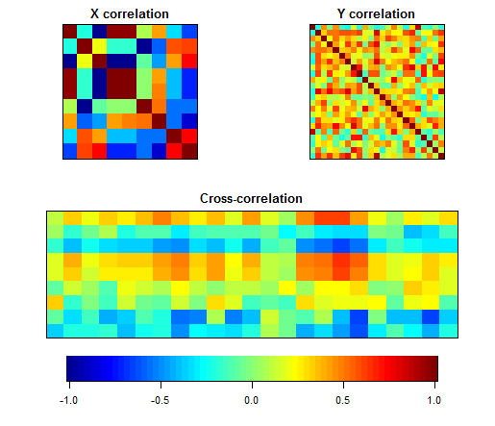

Figure 1. Correlation of environmental factors with parasitoid Hymenoptera abundance in tidal lands of Indragiri Hilir District.  
*Type: High Resolution (HD)*

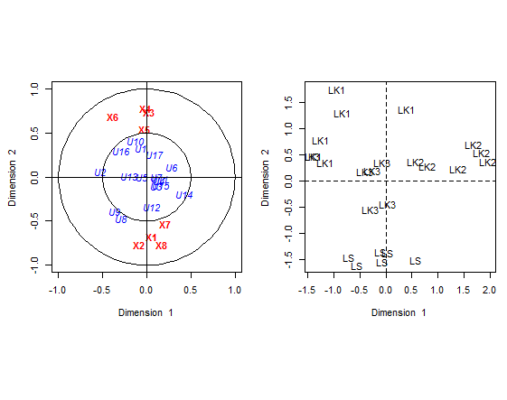

Figure 2. Canonical correlation diagram of landscape type and parasitoid Hymenoptera abundance in tidal lands of Indragiri Hilir District.

**CONCLUSIONS**

1. Contains the conclusions of the research. Answers the research objectives. Short, clear and informative
2. Written in bullet form if more than one conclusion.

**ACKNOWLEDGEMENTS**

Thank you to those who helped materially and non-materially. Whether it is research funders, research facilities providers, or those who help in any way.

**LITERATURE**

Bibliography writing is recommended using library management applications such as Endnote, Mendeley or Zotero. The references cited in the text must be exactly the same as those in the Bibliography, and vice versa.

Citation and bibliography writing uses the **American Psychological Association (APA) system**. In APA format, only the first letter of the title of the paper or additional title is capitalised, except when referring to proper names and Latin names. The bibliography is arranged alphabetically (A-Z), 1 space with 12 afterspace, the second line protrudes inward by 5 beats. The number of references is at least 15 sources with primary references (journals) at least 80%. Referenced sources published in the last 10 years. Unpublished literature and personal communication should not be cited.

1. Journal

Ang, W.F., Teo, S., Lok, A.F.S.L., Suen, S.M., & Ng, B.Y.Q. 2010. Late instar caterpillar and metamorphosis of Spodoptera picta Guerin-Meneville (Lepidoptera: Necotuidae: Noctuinae) with notes on its cannibalistic behavior. Nature in Singapore. 3: 239-244.

Bhatti, Z., Ahmed, A.M., Khatri, I., Rattar, Q., Rajput, S., Tofique, M., & Younas, H. 2020. First report of morphometric identification of Spodoptera frugiperda J.E Smith (Lepidoptera: Noctuidae), an invasive pest of maize in Southern Sindh, Pakistan. Asian J Agric & Biol. Online first. DOI: https://doi.org/10.35495/ajab.2020.03.169.

1. Proceeding

Dirgayana, I.W., & Marsadi, D. 2023. Population and attack percentage Spodoptera litura Fabricius (Lepidoptera: Noctuidae) on tomato plants in Sekaan village, Kintamani district, Bangli regency. Proceedings of The International Conference on Multi-Disciplines Approaches for The Sustainable Development, 385-391. Retrieved from <https://eproceeding.undwi.ac.id/index.php/mdasd/article/view/286>.

1. Books

Kalshoven, L.G.E. 1981. The Pest of Crops in Indonesia. Translated by PA Van der Laan. Jakarta (I.D.): P.T. Ichtiar Baru-Van Hoeve.